Sponsorship Bid for Brew Fest Hotel Rooms
* In kind services will receive sponsorship recognition*
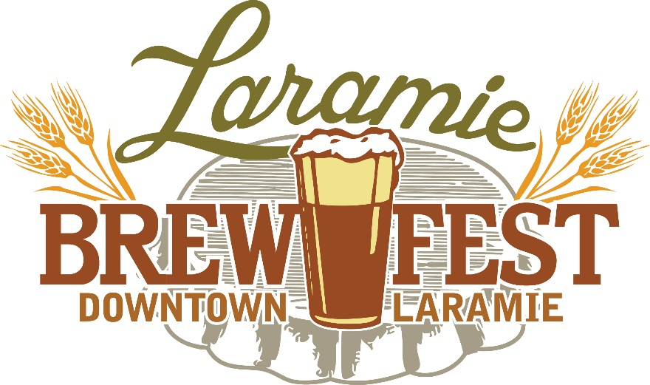

* JULY 13 * 1 – 6 PM * DEPOT PARK *
Laramie Main Street invites you to be part of the 14th annual Brew Fest! Brew Fest continues to be downtown’s premier event with 2,000 plus participants sampling beer, dancing to live music and connecting with friends. Brew Fest is Main Street’s primary fundraiser. Profits from this event are used to promote downtown and are earmarked for special improvement projects like improvements to Third Street, wayfinding signage, holiday lights, bike racks and public art.

BID OFFER

PLEASE DOCUMENT YOUR BID OFFER (Proposed Discount Fees) for 10 hotel rooms the nights of Friday, July 12 and Saturday, July 14. Rooms are for traveling brewery representatives who will be making their own reservations, reimbursable by Main Street with a receipt from the brewery. We are looking for a hotel to reserve a block of rooms at a discounted rate. Any rooms that are not reserved by July 1st could be released.

Regular Room Rate:

Discounted Room Rate:

Is breakfast included? Yes No

Are you interested in combining your in kind donation with a cash donation to be recognized at a higher sponsorship level?*
Yes No

CONTACT INFO

BUSINESS: CONTACT NAME:

PHONE: EMAIL:

Send bids to Denise Marquiss, Brew Fest Event Coordinator at denise@altitudechophouse.com by April 5.

See attached Sponsorship Opportunities to determine your in kind level and recognition benefits.

